EX – 2 a) Shell Script
NAME : ENIYA B A
CLASS : CSE – A
ROLL NO : 230701085
Aim:
To write a Shellscript to to display basic calculator.
Program:
echo &quot;Enter the num1 and num2:&quot;
read n1
read n2
a=`expr $n1 + $n2`
b=`expr $n1 - $n2`
c=`expr $n1 \* $n2`
d=`expr $n1 / $n2`
e=`expr $n1 % $n2`
echo &quot;add $a&quot;
echo &quot;sub $b&quot;
echo &quot;mul $c&quot;
echo &quot;div $d&quot;
echo &quot;mod $e&quot;
OUTPUT :
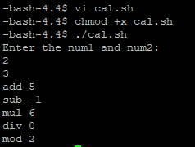
EX – 2 a) Shell Script
Aim:
To write a Shellscript to test given year is leap or not using conditional statement
Program :
echo "Enter the year:"
read y
a=$(expr $y % 4)
b=$(expr $y % 100)
c=$(expr $y % 400)

if [ $a -eq 0 -a $b -ne 0 -o $c -eq 0 ]
then
echo "It is a leap year"
else
echo "It is not a leap year"
fi
OUTPUT :
